Penney’s Wood
Meeting – 30th April 2015

Present:
John Wheatley, Iain Campbell, Kate Somervail, Bronwen Wheatley, Rory Sheenan, Alastair Kerr, Julie King

Apologies:
Helena Thomson

Continuing Agenda:

- Trees, maintenance
- Bridge, paths and grass-cutting
- Drainage
- Dog waste bins
- Community involvement

Trees, maintenance
The contractor, Eamonn Wall, has spot weeded the area and committee members have checked the majority of the trees pulling long grasses and checking for mole-action. Thanks to those who were available to help.

Kate has updated Ian Moss (Woodland Trust) on the progress of the woodland – suggest we send an invite to any event we hold in the Autumn.

The Wallaces are repairing the fence adjoining the Woodland over the next while – permission was granted by the committee

Bridge, paths and grass-cutting
Paths being cut week beginning 5th May if possible – new and existing. Thanks to John and Rory for doing this.

Bridges and benches – Caledonia Play happy to supply sleepers and benches, discussed the design/style. Kate to get a quote for benches and 10ft sleepers for bridges. The suggestion was for approx. four benches. The CP “sleeper bench” design:

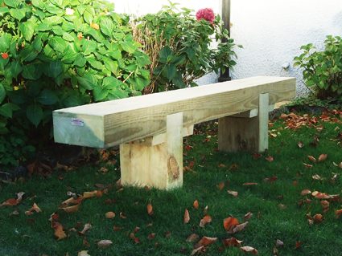

Rory and John will take the lead on installing the bridges, with help from the rest of the committee as necessary. Julie has spare paving slabs which will be used as the bases on either side – thank you, Julie.

West gate – the latch is broken, quick fix required at present. Steps also to be put in using slabs/stone as necessary

Burn clearing and drainage
David Johnman will clear from the corner of the Wallace’s land to the east side of the area in the near future, and before the bridges are put in. David’s advice is that the sheep dip tank should be filled in with earth and levelled rather than removed.
Broken drain – has been cleared

Dog waste bins
Kate has heard from Animal Welfare/Dog Waste at PKC and they think we’d be better with general bins than poop-specific ones – so have passed the enquiry on to Waste Services who will be in touch.

Community involvement
- Fossoway Primary School – the school are interested in using the woodland as an out door classroom/teaching resource. Ewen/Hazel to ask if they’d be able to take part in a litter-pick every few months - ongoing
- Noticeboard – agreed on a lecturn style at the main gate, prices to be looked in to. Wooden signs to be put at the west and south gates
- Social event – it was agreed that it would be good to have an event in the Autumn, date put forward is the 15th of August from 2.30pm onwards. Bring a picnic, with woodland treasure hunt (identify trees/plants/bugs) for children. Committee to supply gazebos. Advertise using posters and a door drop nearer the time.
Website
Julie has looked into name, cost and design:
- www.penneyswood.org.uk - agreed
- £52.88 every 2 years, plus Julie to host the site – agreed, Julie to invoice
Julie has produced a mock-up but requires more info, it was agreed that the following pages would be used:
- Front page – intro and images (Kate)
- Get involved – committee, event etc (Kate)
- History – of the area and the Penneys (Rory/Helena)
- Gallery – images required (all)
- Links – a couple of suggestions already, need more (all)
- Millennium Walk – to link the paths (Bronwen)

Any other business:
Disclaimer – John to ask Woodland Trust for advice

Date of next meeting:
Thursday, 25th June, 7pm at Braefoot (Wheatleys)

